How to Share Files in Office 365

- Long into Office 365 and create a document (Word, PowerPoint, Excel, etc.)
- Generate a link to share from the share button:
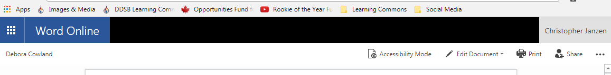
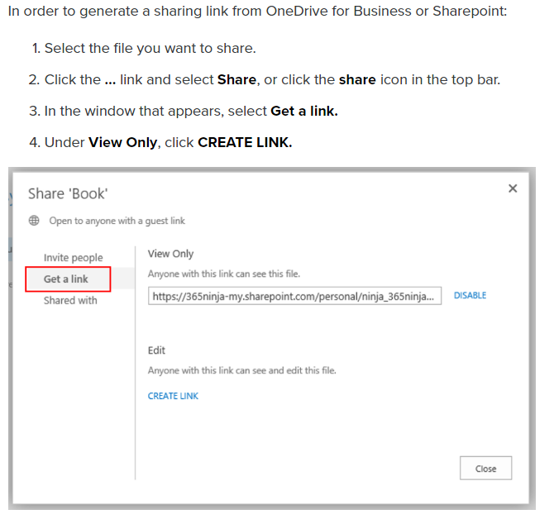
- A link is created to share.

- Use this link to create a shortened URL to share with class:
http://tinyurl.com/

