Vetting Online Sources:
How Do You Know Your Information is Fact and Not Fiction?
Part 1 - the 5Ws
The old formula used by police, journalists, and researchers – Who, What, When, Where, Why, and How – can be applied for internet searches to help identify credible online sources.
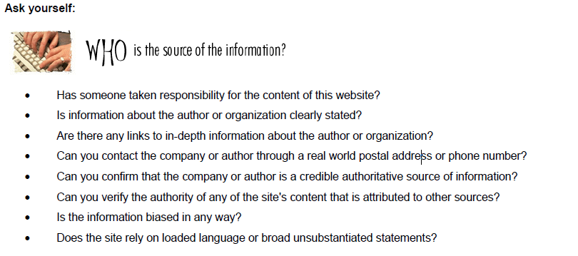
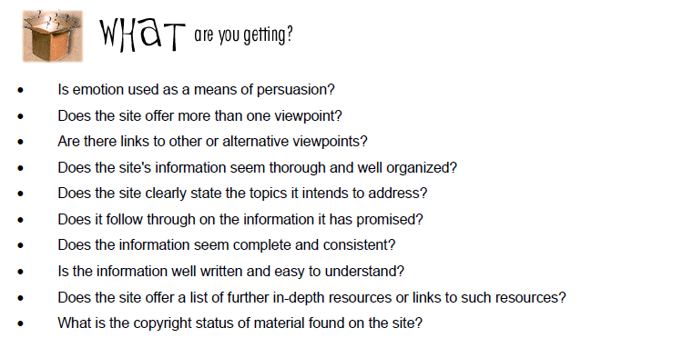

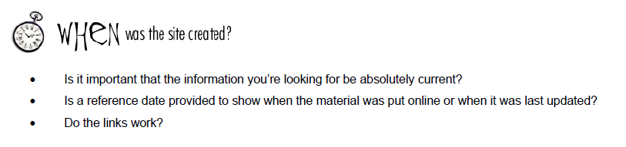

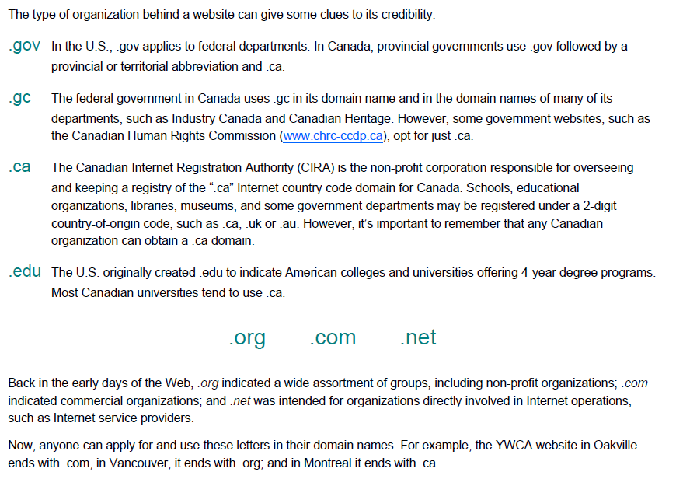
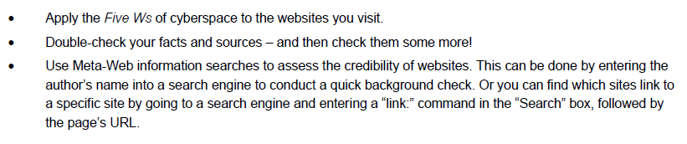
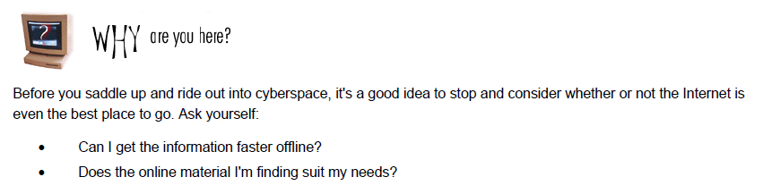
Applying your Knowledge:
Check out the following website and determine if it is a good source of information:
http://zapatopi.net/treeoctopus/
Using the 5Ws, evaluate this source. Explain if it is a reliable source or not and why.
________________________________________________________________________________________________________________________________________________________________________________________________________________________________________________________________________________________________________________________________________________________________________________________________________________________________________________________________________________________________________________________________________________________________________________________________________________________________________________

Part 2 - Tips and Tricks for Better Searches
1. Use quotes to search for an exact phrase
This one’s a well-known, simple trick: searching a phrase in quotes will yield only pages with the same words in the same order as what’s in the quotes. It’s one of the most vital search tips, especially useful if you’re trying to find results containing a specific a phrase.
2. Use an asterisk within quotes to specify unknown or variable words
Here’s a lesser known trick: searching a phrase in quotes with an asterisk replacing a word will search all variations of that phrase. It’s helpful if you’re trying to determine a song from its lyrics, but you couldn’t make out the entire phrase (e.g. “imagine all the * living for today”), or if you’re trying to find all forms of an expression (e.g. “* is thicker than water”).
3. Use the minus sign to eliminate results containing certain words
You’ll want to eliminate results with certain words if you’re trying to search for a term that’s generating a lot of results that aren’t of interest to you. Figure out what terms you’re not interested in (e.g. jaguar -car) and re-run the search.
4. Search websites for keywords
Think of the “site:” function as a Google search that searches only a particular website. If you want to see every time TIME.com mentioned Google, use the search “Google site:TIME.com”.
5. Search news archives going back to the mid-1880s
Google News has an option to search over 100 years’ worth of archived news from newspapers around the world.
6. Compare foods using “vs”
Can’t decide between a burger or pizza for dinner? Type in “rice vs. quinoa,” for example, and you’ll receive side-by-side comparisons of the nutritional facts.

7 . Use a colon to search specific sites
There may be an instance where you need to Google search for articles or content on a certain website. The syntax is very simple and we’ll show you below.
- Sidney Crosby site:nhl.com
This will search for all content about famous hockey player Sidney Crosby, but only on NHL.com. All other search results will be removed. If you need to find specific content on a particular site, this is the shortcut you can use.
8. Using two letter codes to find sources from a particular country.
Using “country codes”, searches are limited to a particular country. “site:KP”
Country Codes are found here: https://goes.gsfc.nasa.gov/text/web_country_codes.html
example for North Korea - site:KP Missile launches
To make the search limited to academic sources, type - site:ac.kp Missile launches

Find sources for your project:
Source #1 - URL _______________________________
Using 5Ws, explain why this is a good source.
__________________________________________________________________________________________________________________________________________________________________________________________________________________________________________
Information collected:
____________________________________________________________________________________________________________________________________________________________________________________________________________________________________________________________________________________________________________________________________________________________________________________________________________________________________________________________________________________

Source #2 - URL _______________________________
Using 5Ws, explain why this is a good source.
__________________________________________________________________________________________________________________________________________________________________________________________________________________________________________
Information collected:
____________________________________________________________________________________________________________________________________________________________________________________________________________________________________________________________________________________________________________________________________________________________________________________________________________________________________________________________________________________

Source #3 - URL _______________________________
Using 5Ws, explain why this is a good source.
__________________________________________________________________________________________________________________________________________________________________________________________________________________________________________
Information collected:
____________________________________________________________________________________________________________________________________________________________________________________________________________________________________________________________________________________________________________________________________________________________________________________________________________________________________________________________________________________

